A Remote Sensing Dust Hazardousness Index Using AOD-Based Frequency, Intensity, and Duration of Dust Storm Events in the Tigris-Euphrates Basin
Mohsen Bakhtiari^{a,b}, Najmeh Neysani Samany^{a,c}, Ali Al-Hemoud^{d}, Kan Huang^{e}, Ali Darvishi Boloorani^{a,c*}
ª Department of Remote Sensing and GIS, Faculty of Geography, University of Tehran, Tehran, Iran
^{b} General Department of Natural Resources and Watershed Management of Alborz Province, Karaj, Iran
^{b} Research Institute for Development of Space Science, Technology, and Applications (RISTA), University of Tehran, Tehran, Iran
^{d} Environment and Life Sciences Research Center, Kuwait Institute for Scientific Research, Kuwait
^{e} Center for Atmospheric Chemistry, Department of Environmental Science and Technology, Fudan University, Shanghai, China

*Corresponding author (ali.darvishi@ut.ac.ir)

Abstract: Dust storms are among the most significant environmental hazards in arid and semi-arid regions, influencing climate, soil stability, vegetation dynamics, and public health. This study develops a basin‑wide dust hazard map by analyzing the Frequency, Intensity, and Duration (FID) of dust storm events (DSEs) across the Tigris–Euphrates Basin (TEB) using 22 years (2001–2022) of MODIS Aerosol Optical Depth (AOD) data. Dusty days were detected using Otsu’s thresholding and a weighted-average (WA) method calibrated against visually interpreted dust source hotspots. The WA-derived thresholds for the AOD band achieved the highest performance (F1‑score: 0.83; overall accuracy: 0.73). Time series analysis reveals pronounced increases in DSEs during 2008, 2009, and 2022, each exceeding 1500 events, while minima occurred in 2002, 2014, 2019, and 2020. Spatial patterns of FID show that the central and southern parts of the basin experience the highest DSE frequency (up to 130 days per year), the strongest intensity, and the longest duration (over six consecutive dusty days). K‑means clustering indicates that severe DSEs are primarily concentrated in the east of major wetlands and across southeastern TEB. Poisson modeling further shows that expected annual DSE frequencies range from the lowest (14–22 days) in Gaziantep in Turkiye to the highest (83–101 days) in Basra in Iraq (68% confidence level). By integrating the FID components, the Remote Sensing Dust Hazardousness Index (RSDHI) was calculated, and the results reveal a distinct northwest–southeast hazard corridor, with major hotspots located around desiccated lakes, wetlands, and southern low‑lying areas. These results provide a robust quantitative assessment of dust dynamics across TEB and offer valuable support for the design of targeted environmental, climatic, and public‑health mitigation strategies.
Keywords: Remote Sensing Dust Hazardousness Index (RSDHI), MODIS-AOD, Frequency, Intensity, and Duration of dust storms, Tigris and Euphrates basin (TEB)
Highlights
- A novel Remote Sensing Dust Hazardousness Index (RSDHI) integrating dust frequency, intensity, and Duration was developed using 22-year MODIS AOD data.
- The Central-south Tigris and Euphrates Basin (TEB) experiences >130 dusty days/year and >6-day dust duration.
- Expected annual dusty days in TEB were lowest (14–22) in Gaziantep (Turkiye) vs. highest (83–101) in Basra (Iraq).
- Introduction
Dust storms are significant meteorological phenomena characterized by widespread, often destructive effects, occurring predominantly in the arid and semi-arid landscapes of subtropical regions (Wu, 2007). They can result from land degradation (Bakhtiari et al., 2021) and wind erosion (Al-Hemoud et al., 2019). The interaction among wind, bare soil, dry atmospheric conditions, and drought facilitates dust storms (Marchese et al., 2017; Jebali et al., 2021), thereby triggering the emission of dust particles into the atmosphere. These particles can travel thousands of kilometers from their source areas and reduce horizontal visibility to less than 1 km (Al-Hemoud et al., 2022). Dust storms have substantial impacts on climate, air quality, soil properties, socioeconomic conditions, and human health in affected regions (Middleton, 2017; Middleton and Al-Hemoud, 2024; Querol et al., 2025; Al-Hemoud et al., 2026). Climate change and anthropogenic activities have altered the frequency of dust storm events (DSEs), intensifying their impacts in many arid and semi-arid regions worldwide, although DSE frequencies have declined in some regions (Middleton and Goudie, 2001; Mehrabi et al., 2015; Darvishi Boloorani et al., 2023a; Darvishi Boloorani et al., 2025). While dust particles generally have detrimental effects on the environment and living organisms, they can also provide positive ecological benefits, such as transporting essential nutrients to marine and terrestrial ecosystems (Soleimani et al., 2020; Aghababaeian et al., 2021; Zheng et al., 2025). Nevertheless, dust storms reduce visibility, disrupt transportation systems (Deng et al., 2011), and exacerbate air pollution (Guo and Chen, 2016), even in areas far from their sources of emission (Middleton, 2017). Estimates indicate that approximately two billion tons of dust particles are transported into the atmosphere annually (Ginoux et al., 2001; Li et al., 2025). Therefore, the detection of dust storms, analysis of particle composition, and identification of dust sources are of considerable importance for predicting and effectively addressing their destructive consequences.
Various types of remote sensing data (Prasad & Singh, 2007; Kaskaoutis et al., 2008; Liu et al., 2011; Bakhtiari et al., 2018; Darvishi Boloorani et al., 2023b) and meteorological station data (Qian et al., 2002; Namdari et al., 2018; Beyranvand et al., 2023; Shirgholami et al., 2025) have been widely used in dust-storm studies. Aerosol Optical Depth (AOD) is defined as a measure of the amount of aerosol particles that attenuate the transmission of light through the atmosphere (Gupta et al., 2018). The MODIS sensors onboard the Terra and Aqua satellites have been widely used in dust studies through AOD retrieval algorithms such as Dark Target (DT) and Deep Blue (DB) (Wei et al., 2019). The DT algorithm retrieves AOD over both land and ocean surfaces and generally performs better under conditions of relatively high aerosol loading (Gupta et al., 2018). In contrast, the DB algorithm is specifically designed for AOD retrieval over highly reflective surfaces, such as deserts, whereas the DT algorithm generally shows reduced accuracy (Song et al., 2021). MODIS aerosol products have been progressively developed through major improvements in both radiometric calibration and aerosol retrieval algorithms (Wei et al., 2019). The MODIS AOD retrieval process facilitates discrimination between dust and non-dust aerosols.
Although major global dust-source regions include the Sahara, the Middle East, Central and Eastern Asia, and parts of central Australia, these sources are predominantly located in hyper-arid, arid, and semi-arid environments (Darvishi Boloorani et al., 2025). Nevertheless, dust storms can occur beyond arid and semi-arid regions, in different seasons and with varying frequencies and intensities (Middleton, 2017). The transboundary Tigris and Euphrates Basin (TEB) in West Asia, owing to its distinctive hydro-political and climatic conditions (Al-Ansari, 2016), has been recognized as a region containing numerous active dust sources (Darvishi Boloorani et al., 2021; Al-Hemoud et al., 2024). The destructive effects of DSEs originating within the TEB can extend thousands of kilometers beyond their source regions (Al-Hemoud et al., 2020). Although various aspects and driving factors of DSEs in the TEB have been investigated in recent decades (Sotoudeheian et al., 2016; Darvishi Boloorani et al., 2020; Darvishi Boloorani et al., 2021; Naghibi et al., 2024), their spatiotemporal patterns have not yet been thoroughly investigated.
Despite the large number of studies conducted in the TEB, the precise assessment of dust hazardousness remains a knowledge gap. To address this gap, the present study develops a spatiotemporal framework for dust hazard characterization based on the Frequency, Intensity, and Duration (FID) of DSEs from 2001 to 2022. The main contributions of this study are: proposing an AOD threshold-based approach for identifying DSEs; mapping the spatiotemporal behavior of dust Frequency, Intensity, and Duration; developing a remotely sensed dust hazard index; and estimating the probability of DSE occurrence in the TEB. Accordingly, this study seeks to answer the following questions: (i) How can dusty days be identified from daily AOD time series? (ii) How can the spatiotemporal behavior of the Frequency, Intensity, and Duration of dusty days be modeled? (iii) How can a comprehensive characterization of dust hazard be derived from FID? and (iv) How can the FID components be used to assess the probability of future dust events?
- Materials and methods
  - Study area
The Tigris and Euphrates basin is shared between Iran, Iraq, Syria, Turkiye, and a northern portion of Saudi Arabia (Figure 1). Dust storms are mainly governed by the interaction of hydrological and climatic factors; hence, drought periods and water control policies have increased dust storms in the TEB over the last two decades (Al-Ansari et al., 2016; Darvishi Boloorani et al., 2020; Naghibi et al., 2024).
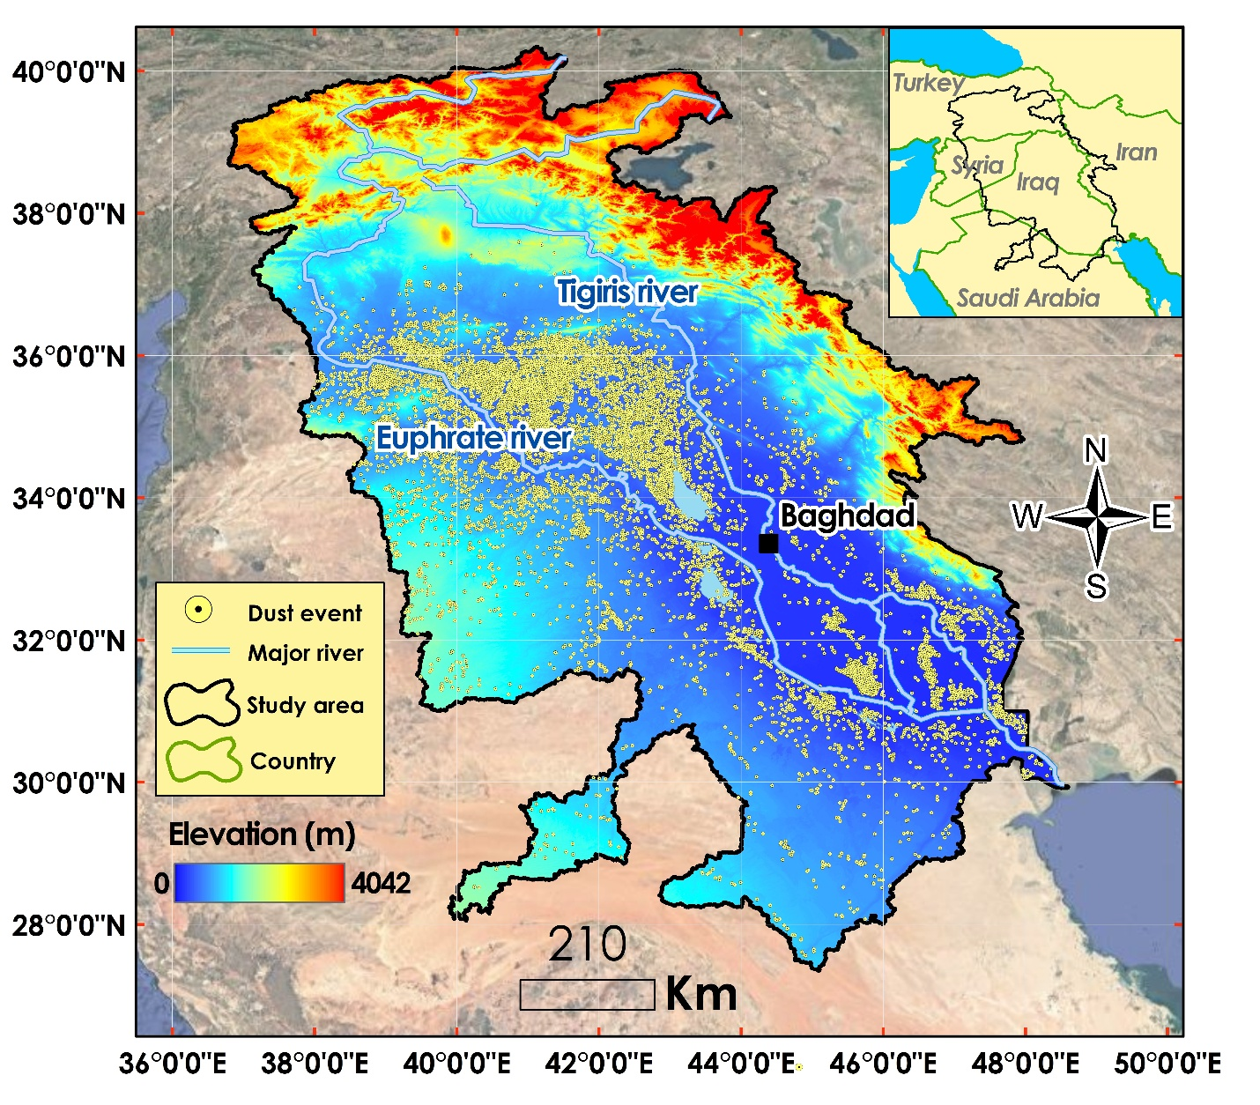
Figure 1. The Tigris and Euphrates basin, featuring geographic boundaries, and reference dust storm points. Dust storm event locations obtained from https://data.mendeley.com/datasets/7937gn7g8c/1 (Darvishi Boloorani et al., 2023c).
  - Dataset
To identify and monitor daily DSEs and extract spatiotemporal indicators, two main data sources were used: the daily AOD time series and the hotspot dust sources map from https://data.mendeley.com/datasets/7937gn7g8c/1.
AOD time series: Daily MODIS-AOD data were used to explore and cluster DSEs. MODIS aerosol DT and DB algorithms retrieve AOD at spectral blue (470 nm) and green (550 nm) bands. The 550 nm band is the most commonly used AOD band (Romano et al., 2013; Xie et al., 2017). To determine the most suitable data for our analysis, we empirically evaluated and compared the retrieval accuracy of both the blue and green AOD bands. Daily time series of MCD19A2.061 products with 1 km resolution, including blue and green bands, were prepared in Google Earth Engine (GEE) for the 2001-2022 period.
Dust hotspots: In this context, 'dust hotspots' refer specifically to the geographically localized emission sources at their time of origin, while 'Dust Storm Events (DSEs)' describe the broader atmospheric manifestation and temporal occurrence of the resulting dust plumes. Dust source hotspots were delineated through visual interpretation of MODIS satellite images over the TEB and were used as reference data in this study (https://data.mendeley.com/datasets/7937gn7g8c/1; Darvishi Boloorani et al., 2023c). Dust hotspot sources have been identified based on DSE; hence, in this study, they served as benchmark dust events to set a threshold for differentiating between dusty and non-dusty days. Each hotspot represents a confirmed DSE, recorded with its acquisition date and geographic coordinates. The dataset provides an event-by-event characterization of dust emission sources from 2001 to 2022 and serves as a reference for calibrating AOD-based thresholds. The hotspot identification workflow combines several complementary data sources, including true-color MODIS imagery, Deep Blue AOD plume patterns, reflectance and thermal anomalies indicative of dust activity, and multi-day temporal tracking to confirm dust plume duration (Darvishi Boloorani et al., 2023c). The hotspot dataset represents a comprehensive long-term, spatially explicit record of dust emissions available for the TEB. They were used as an appropriate and consistent ground reference for calibrating MODIS AOD thresholds.
  - Methodology
Daily AOD measurements from 2001 to 2022, along with the identified dust hotspots of the DSEs, were utilized to identify daily dusty pixels of 1x1 km resolution. As shown in Figure 2, DSEs were entered into Otsu’s thresholding and weighting average (WA) methods (which are detailed and referenced in the subsequent 'AOD Threshold' section) to find the proper threshold. 70% of randomly selected DSEs were used to assess AOD thresholds. The accuracy of the AOD thresholds obtained for both methods was assessed using the remaining 30% of DSE points. More accurate annual AOD thresholds were used to calculate the annual frequency, intensity, and duration of dusty days.
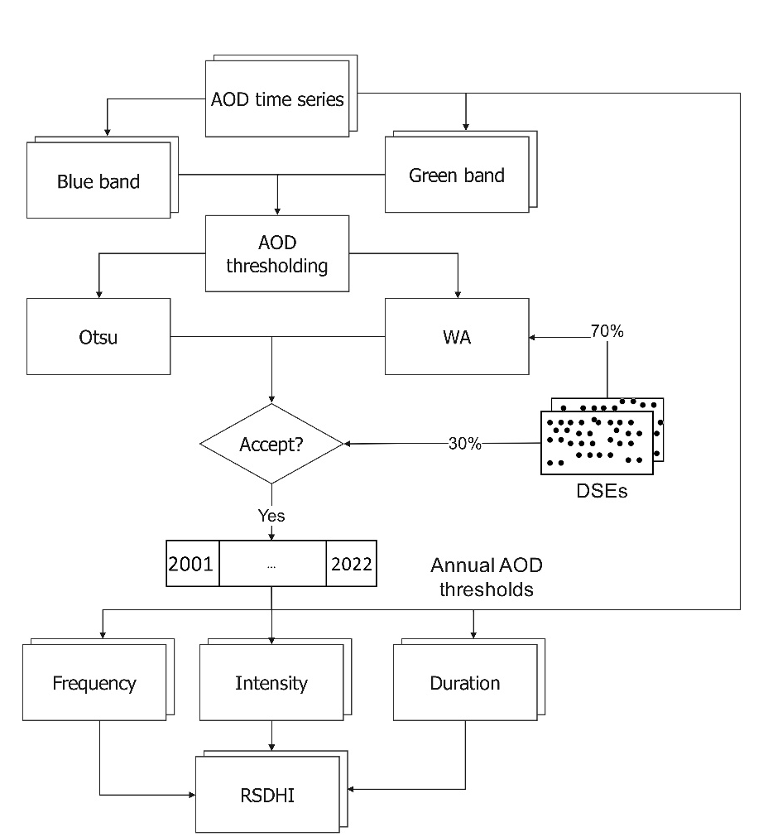
Figure 2. Flowchart of the methodology developed for an AOD-based Remotely Sensed Dust Hazardousness Index.
AOD Threshold: AOD time series do not explicitly reveal dust storms, but are among the most reliable data sources for monitoring changes in the DSE pattern (Kaskaoutis et al., 2008; Xie et al., 2017). Accurate identification of dusty days from MODIS AOD time series requires selecting a threshold that distinguishes dust-laden conditions from background aerosol levels. Two threshold techniques, including Otsu’s method and the weighted average (WA) approach, were evaluated to discriminate dusty days from non-dusty days. Otsu’s method is used for image auto-thresholding, the process of converting a grayscale image into a binary image. It separates an image into two classes, based on the grayscale intensity values of its pixels. Otsu uses the grayscale histogram of an image to detect an optimal threshold that maximizes the interclass variance between the two regions. In other words, the method processes the image histogram and segments the objects by minimizing the variance for each class (Xu et al., 2011; Yang et al., 2020). Accordingly, we used Otsu’s method to discriminate dusty days from non-dusty days by threshold daily AOD time series. Unlike Otsu’s histogram-based segmentation, which does not incorporate dust-event labels, the WA method explicitly integrates AOD values associated with confirmed dust hotspot locations. This allows the threshold to reflect the physical aerosol loading during known dust storm events. Accordingly, we calculated the WA of the randomly selected pixels representing dusty and non‑dusty days as an additional threshold method (Equation 1):
$T_{AOD}=\frac{{(AvAOD}_{dd}×n_{dd})+{(AvAOD}_{nd}×n_{nd})}{N}$ Eq. 1
Where, $T_{AOD}$ indicates the AOD threshold to separate dusty days, ${AvAOD}_{dd}$ and ${AvAOD}_{nd}$ show average AOD for dusty days and non-dusty days, respectively, $n_{dd}$ and $n_{nd}$ show the numbers of selected pixels for dusty and non-dusty days, respectively, and N denotess their sum.
Extract FID of DSEs: Definition and exploration of dust FID illuminates the spatial and temporal dynamics of dust events. The AOD threshold (T_{AOD}) is considered the key parameter for extracting the frequency (Equation 2), intensity (Equation 3), and duration (Equation 5), the three main indicators of dust events.
$$F_{dd}=\sum_{i=1}^{k}{{dd}_{i}}$$ | Eq. 2
Where the frequency of dusty days ($F_{dd})$ is the sum of dusty days (days with AOD ≥ T_{AOD} for a pixel in a specific time period). It is calculated annually from 2001 to 2022, ${dd}_{i}$ is the dusty day in the i^{th} day of the year.
$$DDI=\sum_{i=1}^{k}{{AOD}_{i}-T_{AOD}}$$ | Eq. 3
Where the dusty day intensity (DDI) is the sum of differences between AOD and T_{AOD} for the dusty days. DDI only exists for daily dust pixels.
Eq. 4
Where the dust severity index (DSI) is the product of DDI and F_{dd} for dusty days in a certain pixel.
Finally, the duration of dusty days (D_{dd}) was calculated using Equation 5 as follows:
Eq. 5
Where D_{dd} is defined as the duration of dusty days for a certain area, n_{id} and C_{id} show the number of consecutive dusty days, from 1 to k days, respectively. For example, n_{1d} and C_{1d} represent dusty days that last 1 day and the number of those dusty days, respectively while n_{2d} and C_{2d} denote dusty days that continue 2 days and the number of those dusty events, respectively. The output D_{dd} demonstrates the average annual duration of dusty days for a certain pixel. The basis assumption is that continuous dust event (lasting more than 1 day) has more severe impacts on environmental conditions compare to dust that lasts 1 day. It should be noted that while dust hotspots indicate initial emission events, the resulting elevated AOD can persist in the atmosphere for several days. This temporal lag and prolonged atmospheric loading are intrinsically accounted for in our methodology through the calculation of dust duration (D_{dd}), which tracks the persistence of consecutive dusty days over a given region.
Elimination of the Influence of Non-Dust Aerosols: AODs retrieved by MODIS represent the total columnar aerosol burden and therefore include contributions from urban/industrial pollution, biomass-burning smoke, sea-salt aerosols, and background fine particles. To Eliminate the influence of these non-dust aerosols from dusty-day identification process, several works were carried out: (i) Dust hotspots represent confirmed dust emissions from bare soil, dry lakebeds, and known source areas. AOD values associated with hotspot dates provide dust-dominated atmospheric signals, which serve as reliable training samples for threshold estimation. Because these hotspots correspond to actual emission events, they minimize the likelihood of thresholds for polluted or smoke-dominated days. (ii) AOD retrievals of MODIS-DB are more reliable over bright desert surfaces and more sensitive to coarse-mode particles as a main characteristic of dust (Wei et al., 2019). To reduce contamination from fine-mode aerosols, e.g., pollution and smoke, both blue and green AOD bands were analyzed, consistent with dust’s high coarse-mode contribution and lower sensitivity to fine anthropogenic aerosols. This multispectral preference reduces misclassification of polluted days as dust storms. (iii) Anthropogenic pollution frequently shows diurnal variability and short-lived peaks, whereas dust storms typically persist for several hours to days. To distinguish these phenomena, only days where AOD exceeded the threshold and a spatially coherent plume existed across adjacent pixels were classified as dusty days. Isolated AOD spikes in small urban pixels were excluded unless accompanied by regional plume patterns. (iv) Dust storms generate regionally coherent, advected plumes, while non-dust aerosols are usually localized. Thus, utilizing a spatial neighborhood constraint, a day was labeled as dusty only if 3 adjacent pixels exceeded the threshold, ensuring plume structure typical of dust storms and fine-scale pollution hotspots were filtered out, and (v) During the rainy/transition seasons, pollution can dominate aerosol loading, while dust activity is minimal. Thresholds were applied with the awareness of seasonal dust climatology; days with high AOD but no hotspot-related dust signals during the wet season were not classified as dust storms.
- Results
  - Accuracy assessment of DSEs
To distinguish dusty from non‑dusty days, an annual AOD threshold was performed using both Otsu’s method and the WA approach. Daily AOD observations from 2001 to 2022 were used as inputs. A total of 70% of the identified DSE hotspots were randomly selected each year, and the optimal AOD threshold was then determined for that year. Then, the remaining 30% of dust events were used to assess dusty days based on the assessed T_{AOD}. Finally, the accuracy was measured by comparing the results with the dust hotspot locations map. Hence, F1_score and overall accuracy (for all years, dusty years, and low-dusty years) were calculated for the assessed DSEs of AODs using Otsu’s threshold and WA methods (Table 1).
Table 1. F1_score and overall accuracy of annual DSEs assessed by WA and Otsu’s threshold for both blue and green AODs.
 | WA |  |  |  | Otsu’s thresholding
Selected years |  | Band | F1_score | overall accuracy |  | F1_score | overall accuracy
All years |  | Green | 0.83 | 0.73 |  | 0.71 | 0.62
 |  | Blue | 0.75 | 0.63 |  | 0.69 | 0.58
Dusty years |  | Green | 0.86 | 0.75 |  | 0.69 | 0.58
 |  | Blue | 0.78 | 0.65 |  | 0.68 | 0.56
Low dusty years |  | Green | 0.78 | 0.68 |  | 0.75 | 0.62
 |  | Blue | 0.71 | 0.60 |  | 0.73 | 0.60

The accuracy assessment of the Otsu and WA AOD‑threshold methods for both blue and green showed that the WA‑derived thresholds for the green AOD exhibited the highest accuracy. Figure 3-a presents the AOD thresholds ranging from 0.2 to 0.5 from 2001 to 2022. The average annual AOD map is shown in Figure 3-b. Determining a single appropriate threshold for AOD is often controversial due to the high spatial and temporal variability of background aerosols and the inherent difficulty of isolating dust plumes from anthropogenic pollution (e.g., Kaskaoutis et al., 2008). This study introduces the concept of determining the dynamic threshold for dust according to dust events. Here, it is calculated as an annual threshold, and it can also be calculated on a seasonal, monthly, or daily basis. Although dust activity in the TEB could exhibit seasonality, some factors justify the use of annually derived thresholds: dusty day frequency, intensity, and source activation fluctuate significantly between years due to hydrological, climatic, and land-surface changes. Annual thresholds allow for adaptation to these interannual shifts. Seasonal thresholds may be sensitive to short-term meteorological anomalies (e.g., shifts in synoptic circulation, unusual rain events), whereas annual thresholds smooth these fluctuations and yield a more stable criterion for discriminating dusty and non-dusty days. The assessed range of annual AOD thresholds, i.e., 0.2–0.5, is physically consistent with dust aerosol characteristics in arid and semi-arid environments.

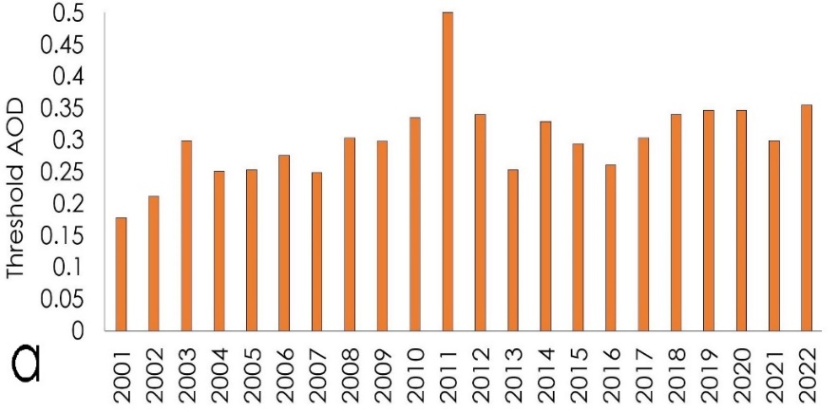
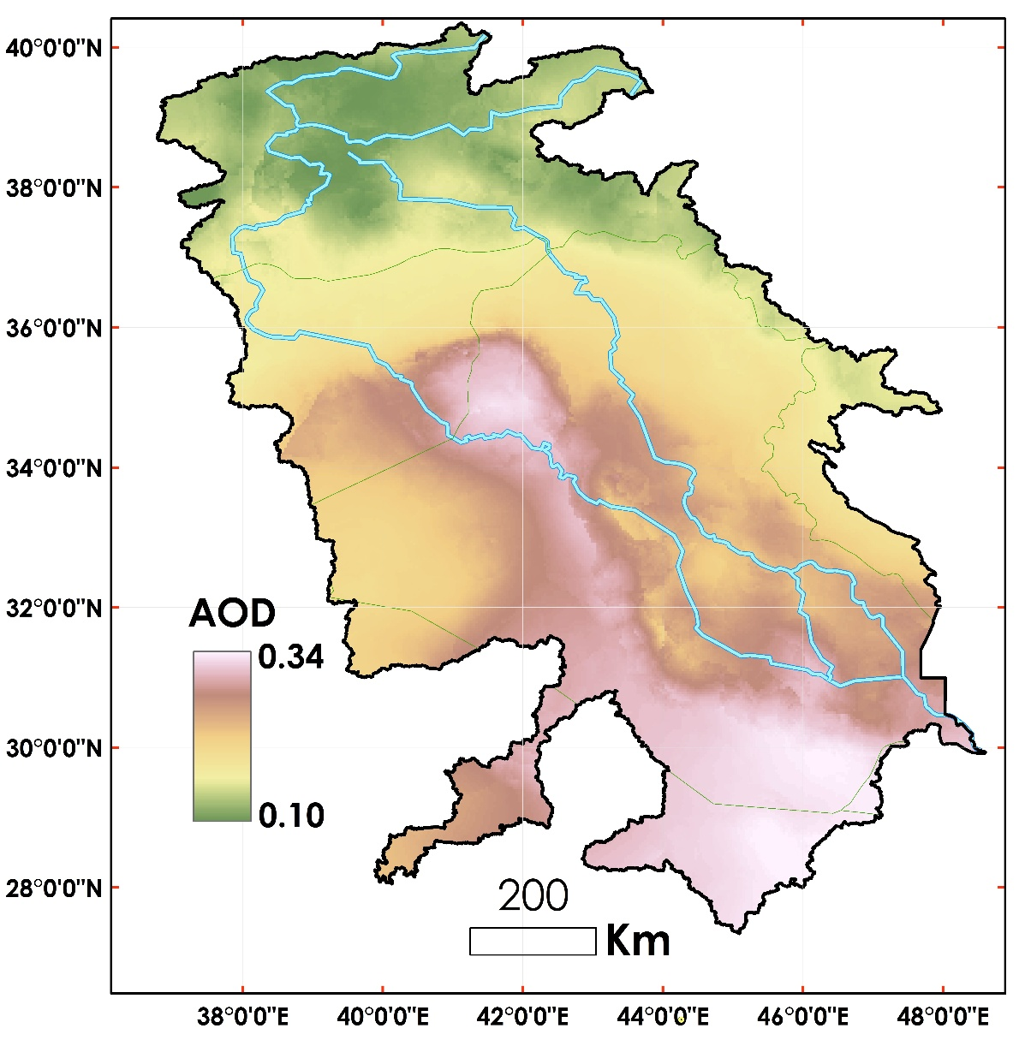
Figure 3. Temporal (a) and Spatial (b) behavior of the AOD thresholds by WA of green AOD in TEB.
  - DSEs monitoring
The number of DSEs and the corresponding average of AODs were calculated annually from 2001 to 2022 (Figure 4). The years 2008, 2009, and 2022, with more than 1500 DSEs, were identified as the dustiest years, while 2002, 2014, 2019, and 2020 were identified as the years with the fewest DSEs. The average AOD of DSEs ranges from 0.25 (2019) to 0.7 (2022). Although AOD values increase in years with more DSEs, the rise is not proportional to the number of dust events. As a result, AOD values alone cannot reflect the intensity and frequency of DSEs. Hence, extracting FID components of dust hazard from the AOD time series could help more precisely understand the spatiotemporal patterns of DSEs.

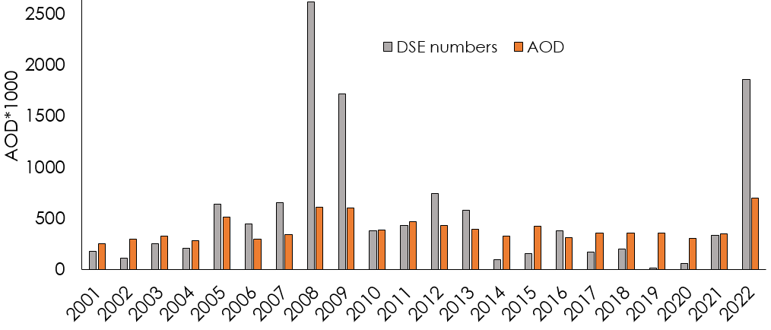
Figure 4. Annual number of DSEs and the corresponding average of AODs. AODs are multiplied by 1000 for easier comparison.
  - Frequency, intensity, and Duration of DSEs
The annual frequency of DSEs was calculated using Equation 2 (Figure 5-a). The average annual dust severity index (DSI) of DSEs (Equation 4) and the average annual duration of dusty days (Equation 5) are shown in Figure 5-b and Figure 5-c, respectively. The maps show a higher incidence of DSEs in the central and southern regions of TEB than in other areas. Severe DSEs have been observed in two central areas and three southeast areas (Figure 5-b). Additionally, a higher concentration of duration of dusty days is observed in the central and southern areas of the TEB (Figure 5-c).
Daily DSIs of dust pixels were categorized using K-means clustering method. Compared with the identified T_{AOD}, we differentiated the no-dust, low-dust, moderate-dust, and severe-dust categories. Figures 5-d, 5-e, and 5-f display the maps representing the number of days with low, moderate, and severe DSEs from 2001 to 2022, respectively. Low and moderate DSEs are predominantly observed in the western regions of central lakes and wetlands, while severe dust events tend to occur in the eastern and southern regions of the TEB.

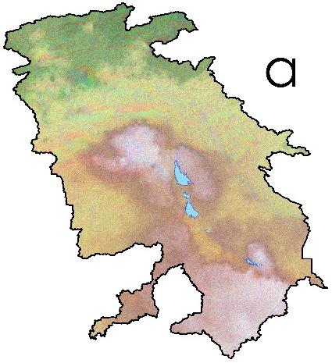 | 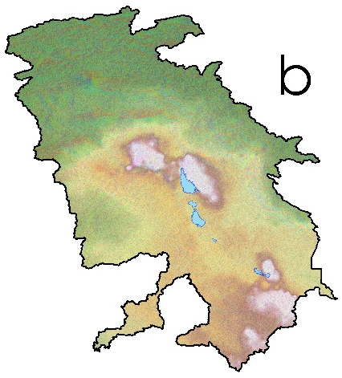 | 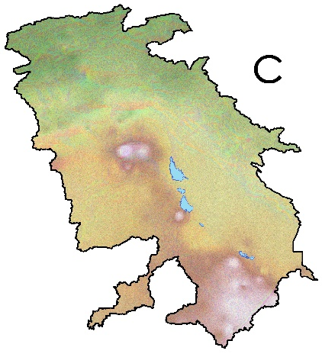
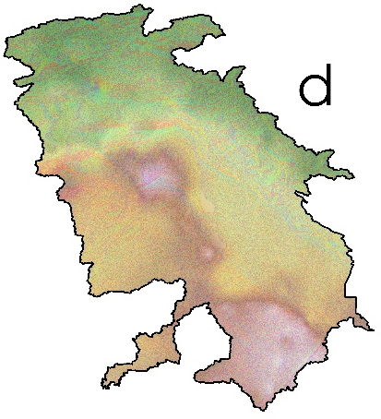 | 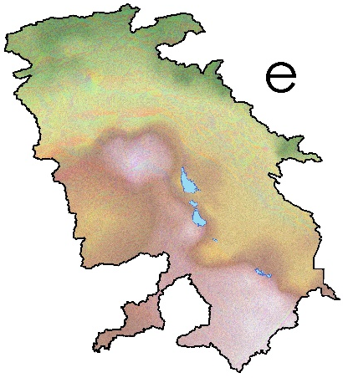 | 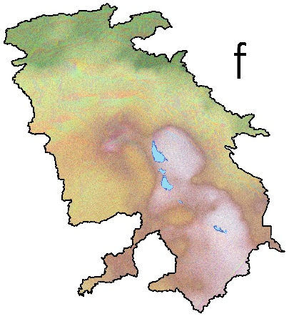
a Average annual F_{dd} min=0 max= 39
b Average annual DSI min=0 max= 39
c Average annual continuous dusty days min=0 max= 39
d Number of days with low DSEs min=6 max= 314
e Number of days with moderate DSEs min=0 max= 1504
f Number of days with severe DSEs min=0 max= 248
Figure 5. Average maps of dust hazardousness components (2001 to 2022). Dust frequency (a), dust severity index (b), duration of dusty days (c), number of days with low DSEs (d), moderate DSEs (e), and severe DSEs (f).
- Discussion
  - FID changes of DSEs
To comprehend and compare the annual trends of dust hazard components: Frequency, Intensity, and Duration, six cities with populations exceeding one million people were selected for a more detailed analysis. They include Gaziantep and Diyarbakir in Turkiye and Mosul, Kirkuk, Baghdad, and Basra in Iraq (Figure 9). K-means clustering was used to classify daily DSI values into discrete intensity levels. The choice of k=3 (low, moderate, severe) is supported by the following several conceptual and empirical considerations: Dust events are commonly described in the literature using three operational intensity levels—low, moderate, and severe dust—based on visibility, aerosol loading, and plume morphology (Hashemi et al., 2025). Applying 3 clusters aligns the clustering with widely accepted hazard categories. Preliminary clustering using k=2–6 was evaluated using the elbow method and silhouette scores (Di Bernardino et al., 2022; Zeinali et al., 2023), Both indicated that k=3 maximize the inter-cluster separation while minimizing intra-cluster variance. Higher k-values produced redundant subclasses without meaningful physical differentiation. Dividing DSEs into three categories ensures interpretability for spatial hazard analysis, decision-making, and communication with environmental agencies. More clusters would complicate interpretation without providing additional actionable insights.
The FID framework, as the hazardousness components, is conceptually grounded in capturing gradations of dust event severity; a three-level scale matches this hierarchical structure. Thus, k=3 is both statistically optimal and operationally meaningful for dust severity classification. Figure 6 (I, III, and V) presents the annual frequency of DSEs and their severity, categorized into three clusters: low, moderate, and severe, for the selected cities. As depicted in Figures 6 (I-Baghdad and I- Gaziantep), Gaziantep and Basra recorded the lowest and highest annual frequencies of DSEs, respectively. Annual observations have indicated high dust severity events in Baghdad and Basra. However, given Baghdad's population over 7 million people (Ali and Al Ramahi, 2020), the number of severe dusty days could potentially increase due to air pollution (Rabee, 2015). The northern cities, including Gaziantep, Diyarbakir, Mosul, and Kirkuk, recorded their maximum frequency of dust events in 2001. In contrast, Baghdad and Basra, located in the south of TEB, experienced their peak dust events in 2005 and 2008, respectively. Figure 6 (II, IV, and VI) delineates four annual clusters of dust duration for the selected cities spanning the period from 2001 to 2022. These clusters, which represent the duration of dust events, are categorized into 1-day, 2-3 days, 4-6 days, and more than 6 days. Gaziantep and Diyarbakir experienced the highest proportion of 1-day DSEs, while Baghdad and Basra exhibited the highest percentage of the most duration of DSEs (those lasting 6 days or more). Baghdad and Kirkuk consistently observed DSEs with duration of 4-6 days throughout the 22-year study. In contrast, Basra, despite having the highest dust frequency, experienced dust events lasting only 1 day and 1-3 days duration of dust events in the years 2005 and 2014, respectively.

 | Baghdad | Gaziantep
I | 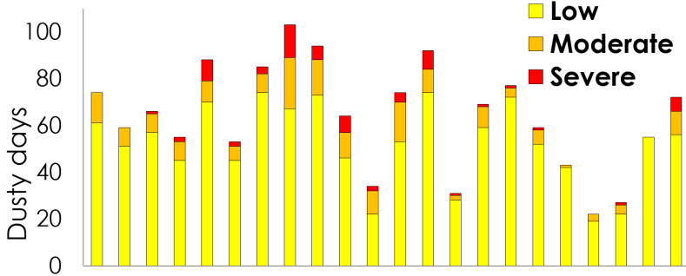 | 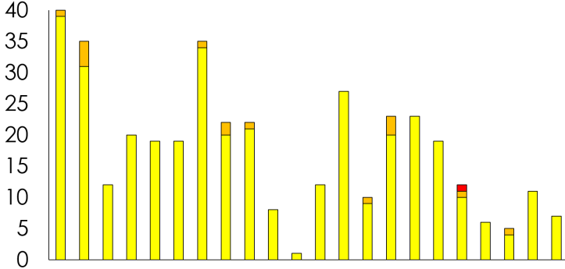
II | 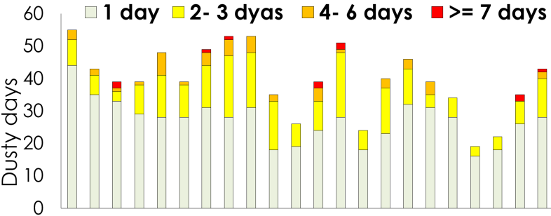 | 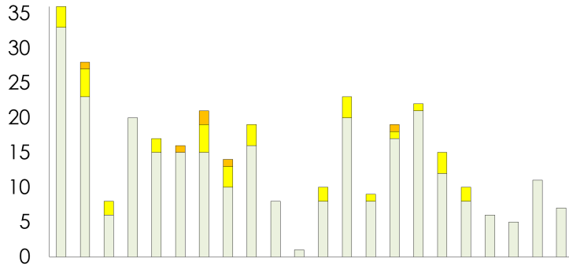
 | Basra | Kirkuk
III | 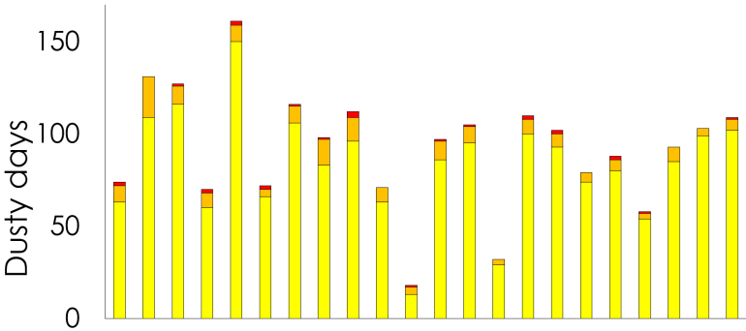 | 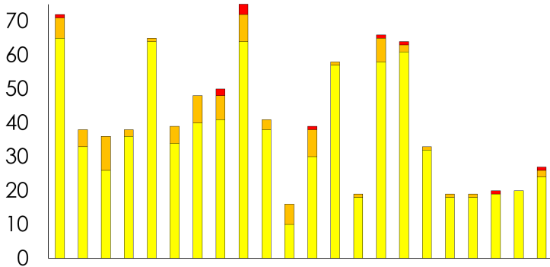
IV | 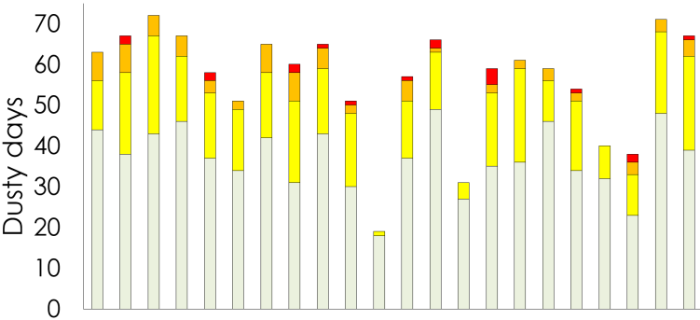 | 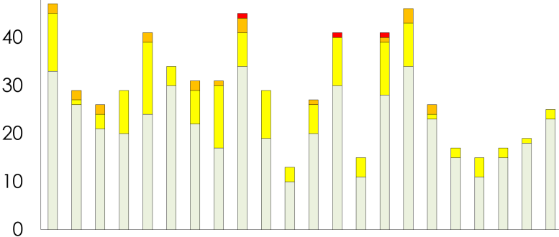
 | Diyarbakir | Mosul
V | 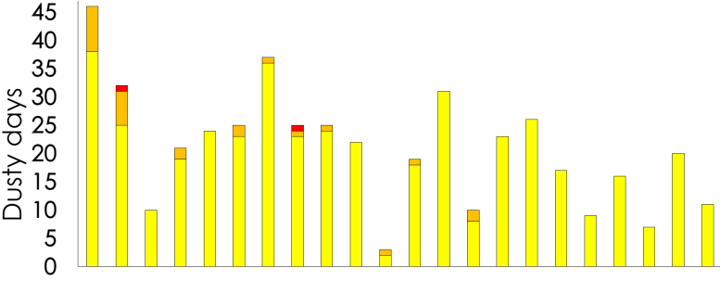 | 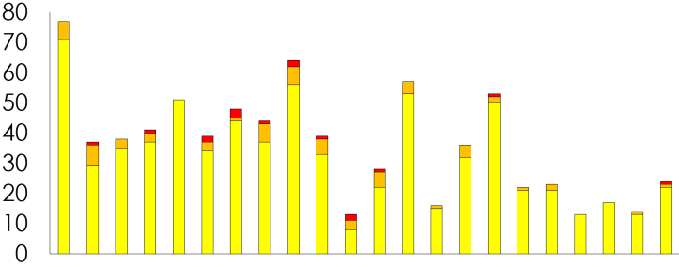
VI | 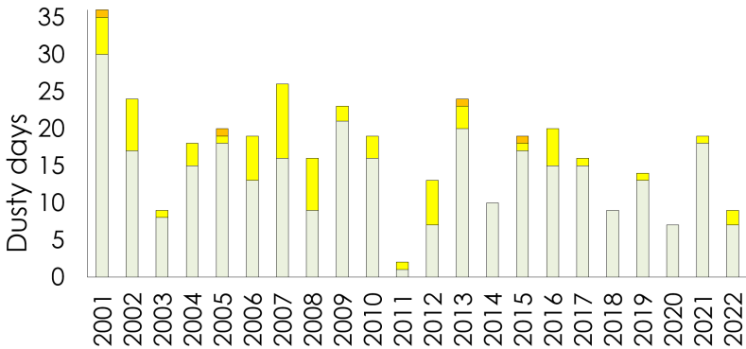 | 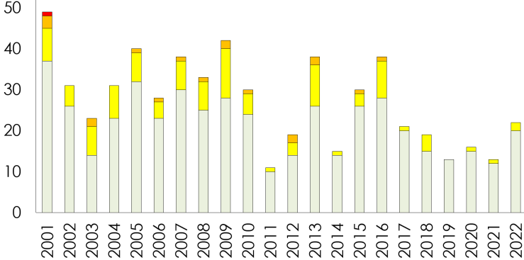
Figure. 6. The frequency and severity clusters and Duration of dusty days in Baghdad (a), Basra (b), Diyarbakir (c), Gaziantep (d), Kirkuk (e), and Mosul (f) from 2001 to 2022. The sum of 3 clusters for each year shows the frequency of dusty days (F_{dd}).
  - Dust probability distribution
Characterizing the probability distributions of DSEs is essential for forecasting future dust hazards and supporting long-term risk management strategies. While this statistical approach provides robust baseline probabilities, it is important to note that fixed-interval models may not fully capture the extreme variability caused by highly aperiodic climate drivers, such as multi-year droughts or El Niño-Southern Oscillation (ENSO) events. From the statistical viewpoint, any dust storm can be studied as an independent and discrete probabilistic event. Consequently, the probability distribution of DSEs can be modeled using Poisson probability distribution (Equation 6). This distribution is typically used to compute the probability of a given number of events or random variables occurring within a fixed time interval. Although dust events exhibit seasonality, autocorrelation, and meteorological dependence, the Poisson distribution remains appropriate for modeling annual counts of DSEs for several reasons: DSEs occur as count-based, discrete events—classic conditions for Poisson processes; Daily dust probability is typically low, but annual totals fall within the range suitable for Poisson modeling (5–150 events/year depending on location). This structure supports the Poisson assumption of infrequent events over fixed intervals. While dust storms may exhibit temporal clustering on daily timescales, using annual aggregates mitigates autocorrelation and seasonal dependence, resulting in near-Poisson yearly totals. Histograms of annual DSE frequencies approximate a unimodal, right-skewed distribution characteristic of Poisson processes. Chi-square and Kolmogorov-Smirnov tests further indicated acceptable goodness-of-fit for annual counts, and λ is defined as the average number of occurrences within a specific period, directly represents the average annual dust frequency, providing a physically meaningful hazard descriptor (Cohen, 1960; Mighell, 1999).
Eq. 6
E(x)= , Var(x)=
Where, f_{x}(x=x) represents the probability of ‘x’ occurrence, E(x) and Var(x) denote the mean and variance of dust counts, respectively.
A common limitation in using Poisson model is the assumption that the mean and variance of event counts are equal. Dust storm events, however, may violate this assumption due to meteorological clustering, drought cycles, or source reactivation. Therefore, we evaluated the presence of overdispersion (Cameron & Trivedi, 1990; Dean, 1992) in the annual dust event counts (2001–2022) for each selected city. For each city, the overdispersion parameter was computed using Equation 7:
$φ=\frac{Var(x)}{E(x)}$ Eq. 7
φ ≈ 1 indicates an appropriate Poisson fit, while if φ > 1.5 indicates clear overdispersion, and finally φ < 1 indicates underdispersion (rare in environmental hazards).
Across the six cities analyzed: (i) φ ranged from 1.02 to 1.31, indicating mild overdispersion but no severe deviation from Poisson behavior, (ii) Likelihood ratio tests comparing Poisson vs. negative binomial models showed that negative binomial parameter k approached infinity (k > 20), which is characteristic of near-Poisson conditions. Thus, although some overdispersion exists, its magnitude is small, and the Poisson model remains statistically appropriate for annual dust counts.
The probability distribution of DSE frequency, severity, and duration of dusty days was computed using the Poisson distribution for daily dust pixels. The outcomes of this dust probability distribution for the selected cities are depicted in Figure 7. The plots of the probability distribution illustrate the probability value (ranging from 0 to 1) of the occurrence of each specific DSE frequency (Figure 7-a and Figure 7-b), severe dusty days (Figure 7-c and Figure 7-d), and duration of dusty days (Figure 7-e and Figure 7-f). The peak values of the distribution signify the average probability. The stretched shape of the distribution suggests a wider expected range of DSE frequencies, while a narrower and taller shape indicates a more limited range of DSE frequencies for a given location. Consequently, we forecast the annual DSE frequencies to be between 5 and 35 for Gaziantep and 60 and 130 for Basra, respectively (Figure 7-a). Other cities show a DSE frequency within these two ranges. The shapes of the probability distributions for severity and duration of dusty days across the selected cities are relatively similar. That is why they are interpreted in the same manner as the shapes of DSE frequencies. It is unlikely (probability less than 0.04) that Gaziantep will experience a severe dust event within a year, whereas Basra is expected to experience three severe dust events annually. Furthermore, it is projected that the annual DSEs in Gaziantep and Basra will exhibit a duration of 1- and 2-days, respectively.
The cumulative probability distribution for DSE frequency indicates that the maximum annual expected DSEs for Gaziantep and Basra are 35 and 130, respectively (Figure 7- b). The likelihood of observing fewer than 70 DSEs in Basra is close to 0, while the probability of Gaziantep experiencing a year with a DSE number <= 10 is approximately 0.5 (Figure 7-b). The cumulative probability of severe dusty days in Gaziantep shows 0.95 for a year without severe DSE, and it is represented by a horizontal line with a constant value of 1, indicating that the probability of experiencing a maximum of one severe dust event is the same as experiencing two or more. The cumulative probability of severe DSEs in other cities shows an upward trend (Figure 7-d). The cumulative probability of the duration of DSEs for all cities is also ascending, with the slope of the curves being a distinctive feature. For instance, the probability that DSEs will last a maximum 3 days in Basra and Gaziantep is approximately 0.85 and 0.96, respectively (Figure 7-f).

- Probability of DSEs frequency =k | b- Accumulative probability of DSEs frequency <=k
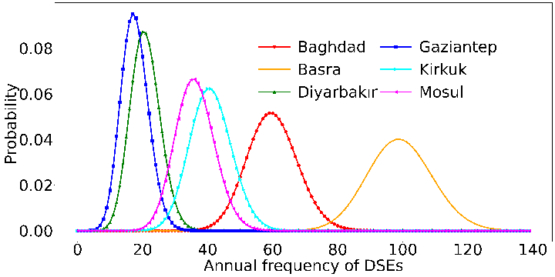 | 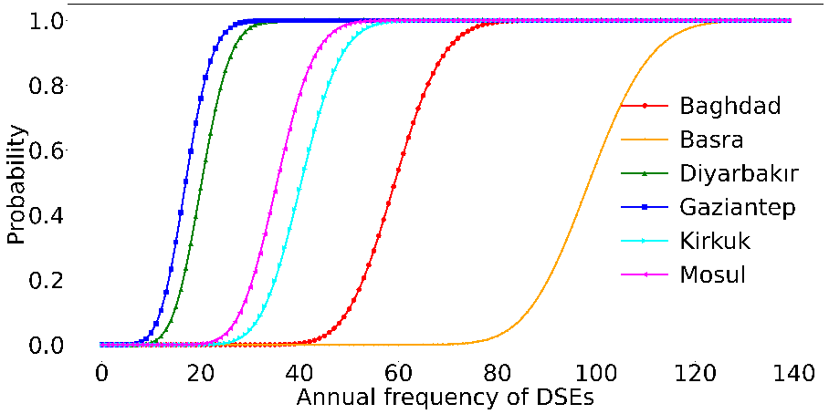
c- Probability of severe dusty days =k | d- The accumulative probability of severe dusty days <=k
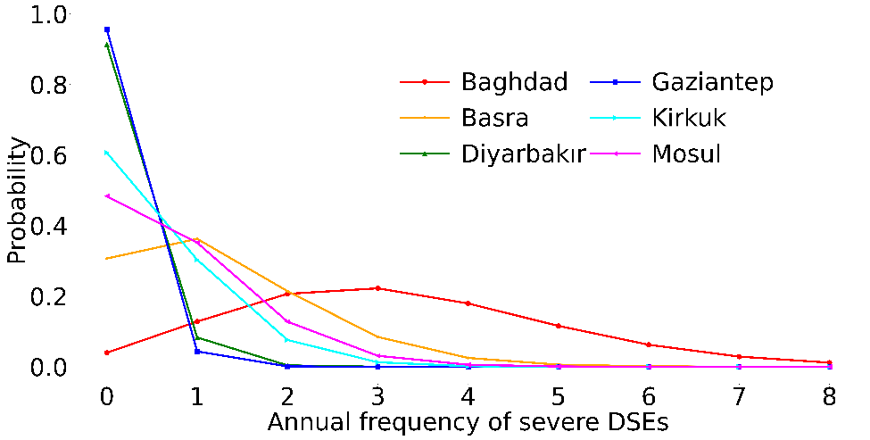 | 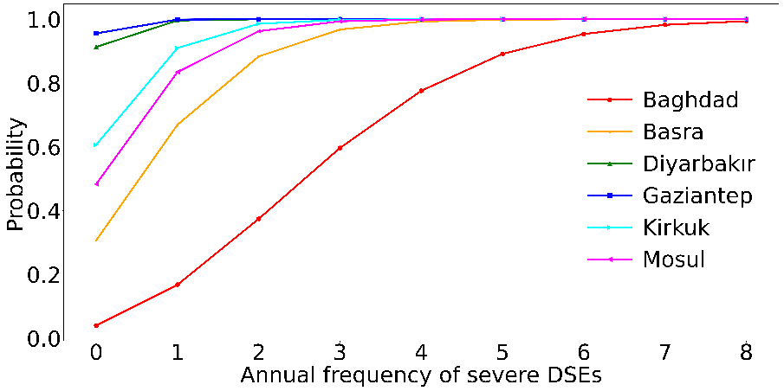
e- Probability of duration of dusty days =k | f- Accumulative probability of duration of dusty days <=k
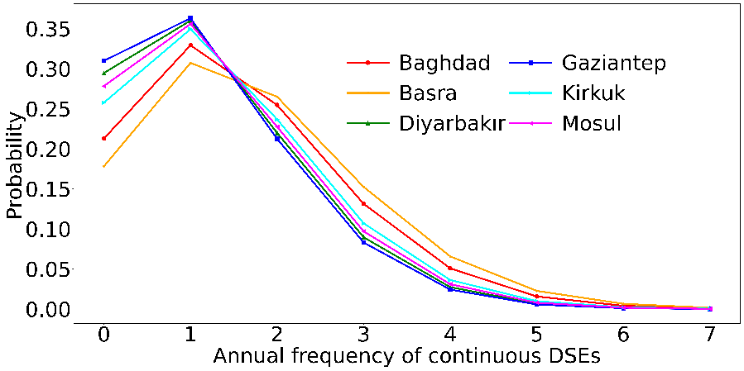 | 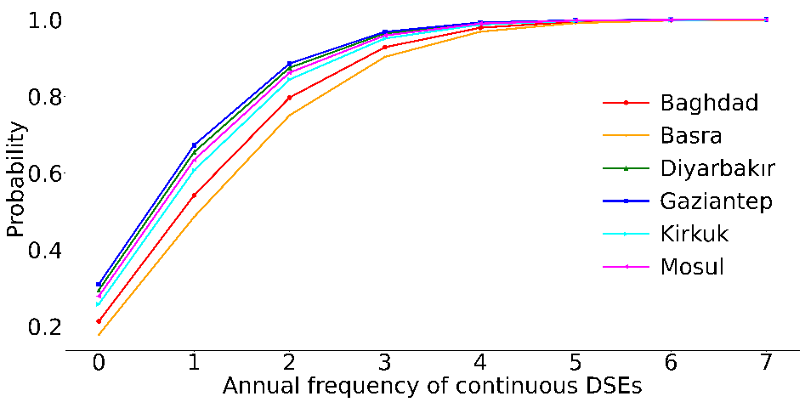
Figure 7. The probability distributions and cumulative probability distributions of DSE frequency (a and b), intensity of dusty days (c and d), and duration of dusty days (e and f) for the selected cities.
The probability distribution curve of dust frequency exhibits a normal distribution (compared to the probability distribution of severity and duration of dusty days). The apparent normal behavior of DSE frequency distributions was also statistically verified. Shapiro–Wilk and Anderson–Darling tests, in combination with QQ plots and skewness analysis (González-Estrada & Cosmes, 2019) indicated that annual DSE counts approximate a normal distribution for most cities.
For annual counts, p-values > 0.05 were obtained from the Shapiro–Wilk test in 4 of 6 cities. Skewness values were low (0.1–0.6), and QQ plots showed approximate linearity. Generally, dust event counts are approximately normal only when they are aggregated annually, over multi-decade time windows, and after mild smoothing via long-term climatology. This near-normal behavior enables the use of normal-based confidence intervals (68–95–99.7%), but we clarify that this is an approximation, not a strict statistical assumption. Therefore, we treat the normal distribution as a useful approximation and use it only estimate confidence intervals for the expected annual dust frequency. Hence, the rules of normal distribution can be used to analyze different DSE frequencies. In the normal distribution curve, three distinct probability or confidence levels have been identified, namely 68%, 95%, and 99.7%. Consequently, we provided the expected ranges of annual DSEs for the selected cities at confidence levels of 68%, 95%, and 99.7% in Table 2. The ranges of DSE numbers within the probability levels for Gaziantep and Basra are expected to be 14 to 22, 10 to 26, 6 to 32, and 83 to 101, 74 to 110, 65 to 119, respectively. The probability levels for the remaining cities vary between those of Gaziantep and Basra (Table 2). In general, applying the probability distribution of DSEs offers valuable insights into the dust-hazard conditions prevalent in these cities. This information can be instrumental in shaping policies and strategies to mitigate the substantial environmental and health impacts associated with dust storms.
Table 2. Expected annual DSEs occurrences in the selected cities at the 68%, 95%, and 99.7% confidence levels.
City | Confidence level
City | 68% | 95% | 99.7%
Baghdad | 56-70 | 49-77 | 42-84
Basra | 83- 101 | 74-110 | 65-119
Diyarbakir | 17-25 | 12-30 | 8-34
Gaziantep | 14-22 | 10-26 | 6-32
Kirkuk | 35-47 | 28-54 | 22-60
Mosul | 30-42 | 24-48 | 18-54

  - Remote Sensing Dust Hazardousness Index
Hazard term denotes the probability of occurrence, within a specified period in each area, of a potentially damaging natural phenomenon (Wilhite, 2000). The hazards of dust storms is regarded as one of the components of dust risk analysis. Since the frequency (Equation 2), intensity (Equation 3), and duration of dust events (Equation 5) describe measures of dust hazard, they could be combined to serve as the Remote Sensing Dust Hazardousness Index (RSDHI). RSDHI can be calculated through three spatial overlay methods, including Sum, Product, and Hedged Product, as Equations 8-10:
$RSDHI_{Sum}= F_{dd}+DSI+C_{dd}$ Eq. 8
$RSDHI_{Product}= F_{dd}×DSI×C_{dd}$ Eq. 9
$RSDHI_{HP}= \sqrt{F_{dd}×DSI×C_{dd}}$ Eq. 10
Where $DHI_{Sum}$, $DHI_{Product}$, $DHI_{HP}$ indicate Remote Sensing Dust Hazardousness Index calculated by Sum, Product, and Hedged Product, respectively. The average annual frequency, intensity, and duration of dusts were normalized and used as inputs to RSDHI. The range of the final RSDHI map varies from 0 to 1, where regions with a value of 0 indicate no dust hazard, and a value of 1 represents the absolute maximum theoretical hazard within the study area based on the highest observed frequency, intensity, and duration.
The output RSDHIs obtained by Sum and Product decrease and increase the difference between the maximum and minimum values, respectively. The Hedged Product shows the differences in a more balanced way (Figure 8). Hence, due to the flexible and nonlinear impact of the Hedged Product, it is recommended as the RSDHI for dust hazardousness analysis. Accordingly, the RSDHI map of the TEB was produced by the Hedged Product (Figure 9). Areas around wetlands and southern regions have been recognized as having high dust hazards over the last two decades (2001 to 2022). In general, the dust hazard belt in the TEB starts in the central region and extends downward in a northwest-southeast direction, covering the southern regions.

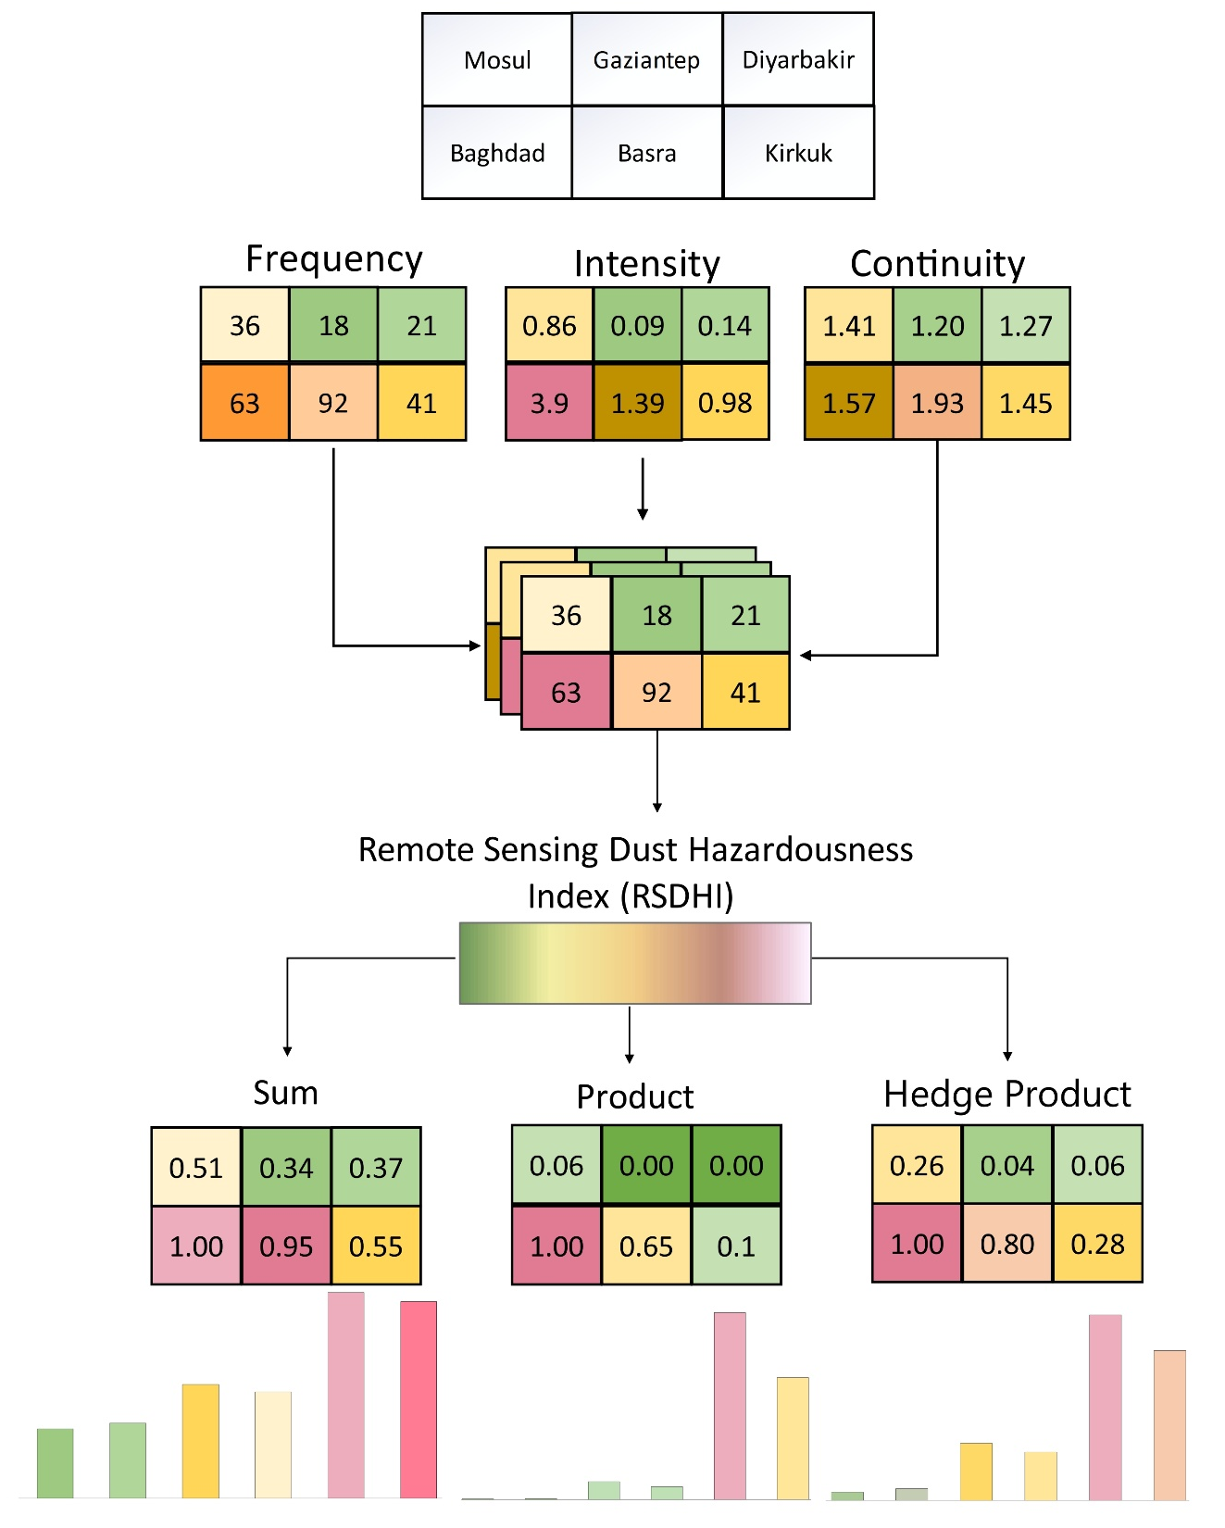
Figure 8. Three methods of combining the annual FID layers of dust events to calculate the Remote Sensing Dust Hazardousness Index (RSDHI) and compare the resulting values ​​in the studied cities.

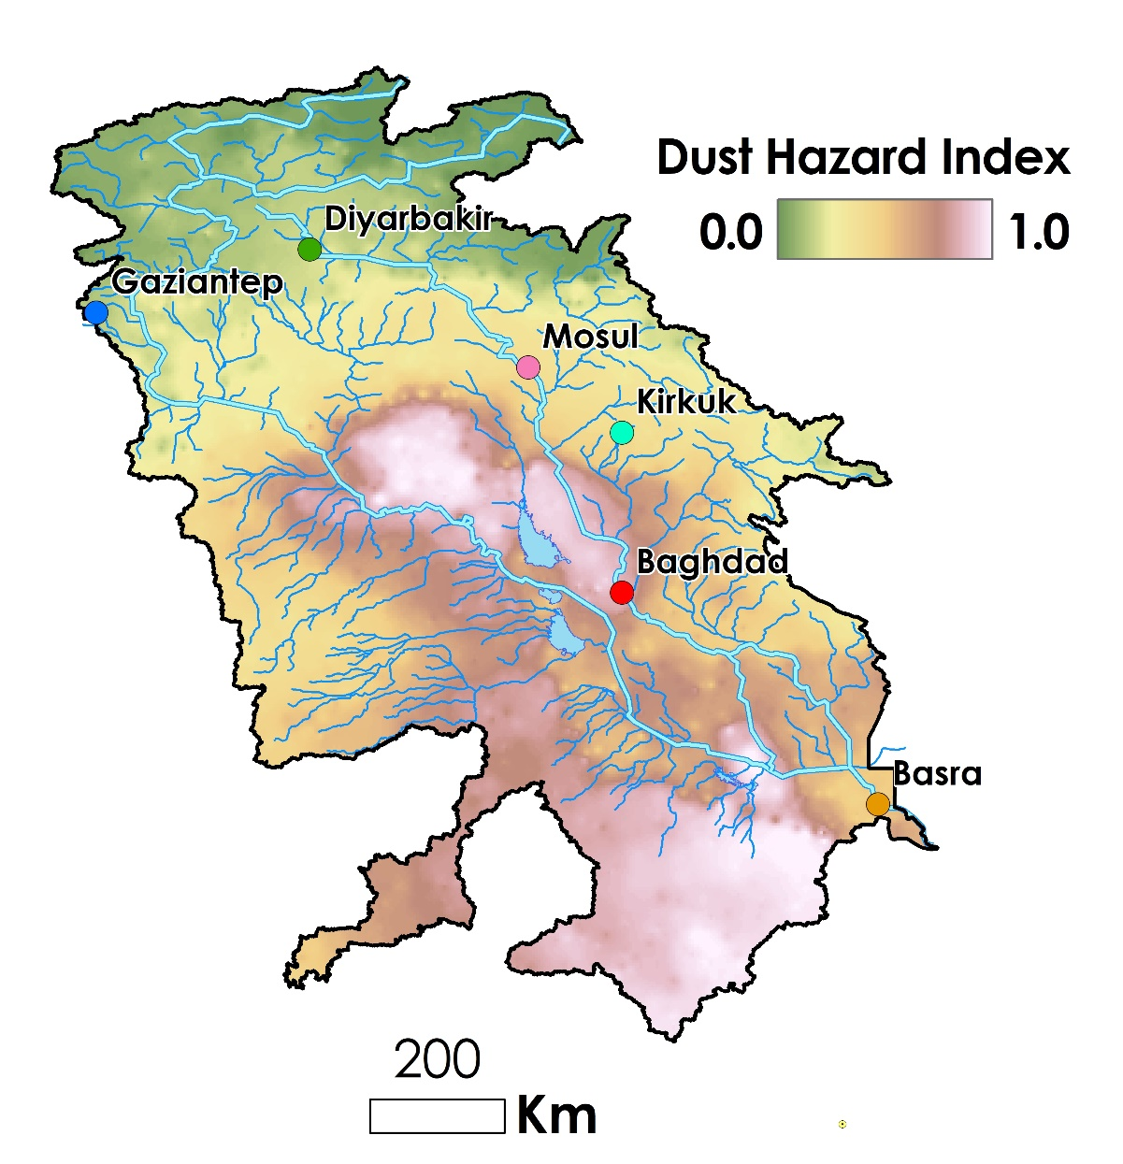
Figure 9. Remote Sensing Dust Hazardousness Index (RSDHI) map calculated using the dust events frequency, intensity, and duration using the Hedged Product method. The colored dots represent the locations of the six major cities selected for detailed analysis.
- Limitations of the Study
Although the RSDHI does a good job of generating spatiotemporal variations in dustiness occurrences, some obvious limitations are worth consideration. First, dust events are observable under relatively cloud-free conditions due to the adoption of MODIS AOD, which may lead to over-deficiency during periods when haze forms due to cloud cover, or to underestimating severe dust pollution that may not coincide with clear days. Secondly, even with carefully chosen spatial filter parameters and thresholds set using satellite retrieval, complex interactions among pollutants and the fine-scale mixture of pollutants in the city may still have limited effect on severity clustering in particular. For example, integrating high-spatial-resolution meteorological conditions with measured urban PM concentration will help define satellite-based thresholds in a further study.
- Conclusion
Significant interannual fluctuations in dust storms are evident across the TEB between 2001 and 2022, with pronounced peaks in specific years rather than a uniform increasing trend; these fluctuations are not directly proportional. Therefore, the extraction of frequency, intensity, and duration of dusty days as the main components of dust storm hazardousness enhances our understanding of the spatiotemporal patterns of this hazardous phenomenon. This study conducted an exhaustive examination of MODIS-AOD time series in the TEB region and yielded significant insights into the hazard posed by dust storms. The study identified annual AOD thresholds using the weighted-average method based on daily AOD and dust hotspot location datasets, establishing a robust framework for distinguishing dusty from non-dusty days. The spatiotemporal behavior of dust storms, as revealed by clustering and probability distribution models, identified the central and southern regions of the TEB as critical dust hotspots. Crucially, the newly developed RSDHI successfully synthesizes these components into a unified spatial metric. The RSDHI reveals a distinct northwest-southeast hazardousness corridor, effectively pinpointing consistently high-risk zones around desiccated wetlands and southern lowlands. This index is a powerful, scalable tool for environmental agencies to map severity, prioritize mitigation efforts, and ultimately reduce the adverse environmental and health impacts of dust storms in the TEB and similar regions across the globe. Future work should focus on integrating additional meteorological data and exploring the socio-economic impacts of dust storms to enhance the comprehensiveness of dust hazardousness assessments.
Acknowledgements
The authors express their gratitude to the support of Iran National Science Foundation (INSF) under project No. 402069, the National Key R&D Program of China (2023YFE0102500), and the National Science Foundation of China (42361144711). The authors also thank the General Department of Natural Resources and Watershed Management of Alborz Province for their valuable support. The authors also express special thanks to the UN-Habitat and the Kuwait Fund for Arab Economic Development for partial funding.

References
Abbas, A. W., Minallh, N., Ahmad, N., Abid, S. A. R., & Khan, M. A. A. (2016). K-Means and ISODATA clustering algorithms for landcover classification using remote sensing. Sindh University Research Journal-SURJ (Science Series), 48(2).
Aghababaeian, H., Ostadtaghizadeh, A., Ardalan, A., Asgary, A., Akbary, M., Yekaninejad, M. S., & Stephens, C. (2021). Global health impacts of dust storms: a systematic review. Environmental health insights, 15, 11786302211018390.
Al-Ansari, N. (2016). Hydro-politics of the Tigris and Euphrates basins. Engineering, 8(3), 140-172.
Al-Hemoud, A., Al-Dashti, H., Al-Saleh, A., Petrov, P., Malek, M., Elhamoud, E., ... & Middleton, N. (2022). Dust storm ‘hot spots’ and transport pathways affecting the Arabian Peninsula. Journal of Atmospheric and Solar-Terrestrial Physics, 238, 105932.
Al-Hemoud, A., Al-Dousari, A., Al-Dashti, H., Petrov, P., Al-Saleh, A., Al-Khafaji, S., ... & Koutrakis, P. (2020). Sand and dust storm trajectories from Iraq Mesopotamian flood plain to Kuwait. Science of the total Environment, 710, 136291.
Al-Hemoud, A., Al-Dousari, A., Misak, R., Al-Sudairawi, M., Naseeb, A., Al-Dashti, H., & Al-Dousari, N. (2019). Economic impact and risk assessment of sand and dust storms (SDS) on the oil and gas industry in Kuwait. Sustainability, 11(1), 200.
Al-Hemoud, A., Naghibi, A., Hashemi, H., Petrov, P., Kamal, H., Al-Senafi, A., ... & Boloorani, A. D. (2024). Dust source susceptibility in the lower Mesopotamian floodplain of Iraq. Remote Sensing Applications: Society and Environment, 36, 101355.
Al-Hemoud, A., Tozer, P. R., Naseeb, A., & Middleton, N. (2026). Economic Impact of Sand and Dust Storms in Kuwait. Economics of Disasters and Climate Change, 10(1), 5.
Ali, A. K. M., & Al Ramahi, F. K. M. (2020). A study of the effect of urbanization on annual evaporation rates in Baghdad city using remote sensing. Iraqi Journal of Science, 2142-2149.
Bakhtiari, M., Darvishi Boloorani, A., Kakroodi, A. A., Rangzan, K., & Mousivand, A. (2021). Land degradation modeling of dust storm sources using MODIS and meteorological time series data. Journal of Arid Environments, 190, 104507.
Bakhtiari, M., Darvishi Bolorani, A., Abdollahi Kakroodi, A., & Rangzan, K. (2018). The trending of normalized health environmental index based on satellite data from 2001 to 2013 and its relation with dust sources in the West Asia. Scientific-Research Quarterly of Geographical Data (SEPEHR), 27(106), 87-99.
Beyranvand, A., Azizi, G., Alizadeh, O., & Darvishi Boloorani, A. (2023). Dust in Western Iran: the emergence of new sources in response to shrinking water bodies. Scientific Reports, 13(1), 16158.
Cameron, A. C., & Trivedi, P. K. (1990). Regression-based tests for overdispersion in the Poisson model. Journal of econometrics, 46(3), 347-364.
Cohen, A. C. (1960). Estimating the parameter in a conditional Poisson distribution. Biometrics, 16(2), 203-211.
Darvishi Boloorani, A., Kazemi, Y., Sadeghi, A., Shorabeh, S. N., & Argany, M. (2020). Identification of dust sources using long term satellite and climatic data: A case study of Tigris and Euphrates basin. Atmospheric Environment, 224, 117299.
Darvishi Boloorani, A., Papi, R., Soleimani, M., Karami, L., Amiri, F., & Samany, N. N. (2021). Water bodies changes in Tigris and Euphrates basin has impacted dust storms phenomena. Aeolian Research, 50, 100698.
Darvishi Boloorani, A., Soleimani, M., Papi, R., Neysani Samany, N., Teymouri, P., & Soleimani, Z. (2023a). Sources, drivers, and impacts of sand and dust storms: A global view. In Dust and Health: Challenges and Solutions (pp. 31-49). Springer International Publishing.
Darvishi Boloorani, A., Bakhtiari, M., Samany, N. N., Papi, R., Soleimani, M., Mirzaei, S., & Bahrami, H. A. (2023b). Land degradability mapping using remote sensing data and soil chemical properties. Remote Sensing Applications: Society and Environment, 32, 101027.
Darvishi Boloorani, A., Papi, R., Soleimani, M., Al-Hemoud, A., Amiri, F., Karami, L., Samany, N.N., Bakhtiari, M. and Mirzaei, S. (2023c). Visual interpretation of satellite imagery for hotspot dust sources identification. Remote Sensing Applications: Society and Environment, 29, 100888.
Darvishi Boloorani, A., Soleimani, M., Papi, R., Nasiri, N., Amiri, F., Neysani Samany, N., ... & Al-Hemoud, A. (2025). Global map of characterized dust sources using multisource remote sensing data. Scientific Reports, 15(1), 29805.
Dean, C. B. (1992). Testing for overdispersion in Poisson and binomial regression models. Journal of the American Statistical Association, 87(418), 451-457.
Deng, J., Wang, T., Jiang, Z., Xie, M., Zhang, R., Huang, X., & Zhu, J. (2011). Characterization of visibility and its affecting factors over Nanjing, China. Atmospheric Research, 101(3), 681-691.
Di Bernardino, A., Iannarelli, A. M., Casadio, S., Pisacane, G., Mevi, G., & Cacciani, M. (2022). Classification of synoptic and local-scale wind patterns using k-means clustering in a Tyrrhenian coastal area (Italy). Meteorology and Atmospheric Physics, 134(2), 30.
Ginoux, P., Chin, M., Tegen, I., Prospero, J. M., Holben, B., Dubovik, O., & Lin, S. J. (2001). Sources and distributions of dust aerosols simulated with the GOCART model. Journal of Geophysical Research: Atmospheres, 106(D17), 20255-20273.
González-Estrada, E., & Cosmes, W. (2019). Shapiro–Wilk test for skew normal distributions based on data transformations. Journal of Statistical Computation and Simulation, 89(17), 3258-3272.
Guo, S. J., & Chen, M. (2016). Pollution characteristic of atmospheric carbonyls during one haze event in Nanning, South China. Aerosol and Air Quality Research, 16(5), 1143-1151.
Gupta, P., Remer, L. A., Levy, R. C., & Mattoo, S. (2018). Validation of MODIS 3 km land aerosol optical depth from NASA's EOS Terra and Aqua missions. Atmospheric Measurement Techniques, 11(5), 3145-3159.
Hashemi, H., Abdi, A. M., Naghibi, A., Zhao, P., Brogaard, S., Haghighi, A. T., & Mansourian, A. (2025). Unraveling the link between agricultural patterns and dust storm occurrence in Mesopotamia. Environmental Research Letters, 20(2), 024011.
Jebali, A., Zare, M., Ekhtesasi, M. R., & Jafari, R. (2021). A new threshold free dust storm detection index based on MODIS reflectance and thermal bands. GIScience & Remote Sensing, 58(8), 1369-1394.
Kaskaoutis, D. G., Kambezidis, H. D., Nastos, P. T., & Kosmopoulos, P. G. (2008). Study on an intense dust storm over Greece. Atmospheric Environment, 42(29), 6884-6896.
Li, T., Cohen, A. J., Krzyzanowski, M., Zhang, C., Gumy, S., Mudu, P., ... & Shen, H. (2025). Sand and dust storms: a growing global health threat calls for international health studies to support policy action. The Lancet Planetary Health, 9(1), e34-e40.
Liu, Z., Liu, Q., Lin, H. C., Schwartz, C. S., Lee, Y. H., & Wang, T. (2011). Three‐dimensional variational assimilation of MODIS aerosol optical depth: Implementation and application to a dust storm over East Asia. Journal of Geophysical Research: Atmospheres, 116(D23).
Marchese, F., Sannazzaro, F., Falconieri, A., Filizzola, C., Pergola, N., & Tramutoli, V. (2017). An enhanced satellite-based algorithm for detecting and tracking dust outbreaks by means of SEVIRI data. Remote Sensing, 9(6), 537.
Mehrabi, S., Soltani, S., & Jafari, R. (2015). Analyzing the relationship between dust storm occurrence and climatic parameters. Journal of Science and Technology of Agriculture and Natural Resources, 19(71), 69-81.
Middleton, N. J. (2017). Desert dust hazards: A global review. Aeolian research, 24, 53-63.
Middleton, N. J., & Goudie, A. S. (2001). Saharan dust: sources and trajectories. Transactions of the Institute of British Geographers, 26(2), 165-181.
Middleton, N., & Al-Hemoud, A. (2024). Sand and dust storms: recent developments in impact mitigation. Sustainability, 16(16), 7121.
Mighell, K. J. (1999). Parameter estimation in astronomy with poisson-distributed data. I. the χγ2 statistic. The Astrophysical Journal, 518(1), 380.
Naghibi, A., Hashemi, H., Zhao, P., Brogaard, S., Eklund, L., Hassan, H. H., & Mansourian, A. (2024). Spatiotemporal variability of dust storm source susceptibility during wet and dry periods: The Tigris-Euphrates River Basin. Atmospheric Pollution Research, 15(1), 101953.
Namdari, S., Karimi, N., Sorooshian, A., Mohammadi, G., & Sehatkashani, S. (2018). Impacts of climate and synoptic fluctuations on dust storm activity over the Middle East. Atmospheric environment, 173, 265-276.
Prasad, A. K., & Singh, R. P. (2007). Changes in aerosol parameters during major dust storm events (2001–2005) over the Indo‐Gangetic Plains using AERONET and MODIS data. Journal of Geophysical Research: Atmospheres, 112(D9).
Qian, W., Quan, L., & Shi, S. (2002). Variations of the dust storm in China and its climatic control. Journal of climate, 15(10), 1216-1229.
Querol, X., Fussell, J. C., Saliba, N. A., Al-Hemoud, A., Nadeau, K. C., Tobías, A., ... & Hopke, P. K. (2025). Desert Sand and Dust Storms and Desert Dust Episodes: Major Patterns to be Accounted for to Protect the Health of Exposed Population: A Review. ACS Es&t Air, 2(12), 2731-2752.
Rabee, A. M. (2015). Estimating the health risks associated with air pollution in Baghdad City, Iraq. Environmental monitoring and assessment, 187, 1-12.
Romano, F., Ricciardelli, E., Cimini, D., Paola, F. D., & Viggiano, M. (2013). Dust Detection and Optical Depth Retrieval Using MSG-SEVIRI Data. Atmosphere, 4(1), 35-47.
Shirgholami, M., Rousta, I., Olafsson, H., Petracchini, F., & Krzyszczak, J. (2025). Tracing the Dust: Two Decades of Dust Storm Dynamics in Yazd Province from Ground-Based and Satellite Aerosol Observations. Atmosphere, 16(11), 1242.
Soleimani, Z., Teymouri, P., Darvishi Boloorani, A., Mesdaghinia, A., Middleton, N., & Griffin, D. W. (2020). An overview of bioaerosol load and health impacts associated with dust storms: A focus on the Middle East. Atmospheric Environment, 223, 117187.
Song, Q., Zhang, Z., Yu, H., Ginoux, P., & Shen, J. (2021). Global dust optical depth climatology derived from CALIOP and MODIS aerosol retrievals on decadal timescales: regional and interannual variability. Atmospheric Chemistry and Physics, 21(17), 13369-13395.
Sotoudeheian, S., Salim, R., & Arhami, M. (2016). Impact of Middle Eastern dust sources on PM10 in Iran: Highlighting the impact of Tigris‐Euphrates basin sources and Lake Urmia desiccation. Journal of Geophysical Research: Atmospheres, 121(23), 14-018.
Wei, J., Li, Z., Peng, Y., & Sun, L. (2019). MODIS Collection 6.1 aerosol optical depth products over land and ocean: validation and comparison. Atmospheric Environment, 201, 428-440.
Wilhite, D. A. (2000). Drought planning and risk assessment: Status and future directions. Annals of Arid Zone, 39(3), 211-230.
Wu, L. (2007). Impact of Saharan air layer on hurricane peak intensity. Geophysical research letters, 34(9).
Xie, Y., Zhang, W., & Qu, J. J. (2017). Detection of Asian dust storm using MODIS measurements. Remote Sensing, 9(8), 869.
Xu, X., Xu, S., Jin, L., & Song, E. (2011). Characteristic analysis of Otsu threshold and its applications. Pattern recognition letters, 32(7), 956-961.
Yang, P., Song, W., Zhao, X., Zheng, R., & Qingge, L. (2020). An improved Otsu threshold segmentation algorithm. International Journal of Computational Science and Engineering, 22(1), 146-153.
Zeinali, B., juq, F. V. G., Teymouri, M., Das, S., Ruhi, F., & Sihag, P. (2023). Selection of the best clustering technique in order to zone the frequency of dust storms in Iran. Arabian Journal of Geosciences, 16(1), 74.
Zheng, Z., Luo, H., Wang, P., & Chen, Z. (2025). Sand and Dust Storms Drivers: A 22 Years Global Bibliometric Evolution. Earth Systems and Environment, 1-17.

